The Ontology for Biomedical Investigations
In alphabetical order: Ryan Brinkman 1, Bill Bug 2, Marcus C. Chibucos, Kevin Clancy 3, Mélanie Courtot 1, Dirk Derom 4, Liju Fan 5, Jennifer Fostel 6, Gilberto Fragoso 7, Frank Gibson 8, Michelle Giglio, Yongqun He 9, Tina Hernandez-Boussard 10, Phillip Lord 11, Allyson L. Lister 11,12, James Malone 13, Monnie McGee 14, Elisabetta Manduchi 15, Norman Morrison 16,17, Helen Parkinson 13, Bjoern Peters 18, Philippe Rocca-Serra 13, Alan Ruttenberg 19, Susanna-Assunta Sansone 13, Richard H. Scheuermann 20, Daniel Schober 21, Barry Smith 22, Larisa N. Soldatova 23, Christian J. Stoeckert Jr. 15, Chris F Taylor 13,17, Jessica A. Turner, Patricia L. Whetzel 24, Jie Zheng 15 plus those working on it now – Carlo, Melissa, Anita, others, ..

1 | Terry Fox Laboratory, BC Cancer Agency, Vancouver, BC, Canada
2 | Laboratory of Bioimaging and Anatomical Informatics in the Department of Neurobiology and Anatomy, Drexel University College of Medicine, USA
_3 | Invitrogen: Life technologies, 5791 Van Allen Way, Carlsbad CA 92008, USA
4 | School of Psychology, Victoria University of Wellington, New Zealand
5 | ?
6 | National Toxicology Program, NIEHS, NIH, Research Triangle Park, NC, 27709, USA
7 | Center for Biomedical Informatics and Information Technology, NIH/NCI, Rockville, MD, USA
8 | Abcam plc, Cambridge UK
9 | University of Michigan Medical School, Ann Arbor, MI, USA.
10 | Stanford University, Dept. of Surgery Stanford, CA 94305, USA
11 | School of Computing Science, Newcastle University, NE1 7RU, UK
12 | Institute for Ageing and Health, Newcastle University, Campus for Ageing and Vitality, Newcastle upon Tyne NE4 5PL, UK
13 | EMBL-EBI, Wellcome Trust Genome Campus, Hinxton, Cambridgeshire, CB10 1SD, UK
14 | Southern Methodist University, Dallas, Texas, 75275, USA
15 | University of Pennsylvania School of Medicine, Philadelphia, PA 19104, USA
16 | School of Computer Science, Kilburn Building, University of Manchester, Oxford Road, MANCHESTER, M13 9PL., UK
17 | NERC Environmental Bioinformatics Centre. CEH Oxford, Mansfield Rd, Oxford OX1 3SR, UK.
18 | La Jolla Institute for Allergy and Immunology, La Jolla, California, USA
19 | Science Commons, Cambridge, MA, USA
20 | University of Texas Southwestern Medical Center, Dallas, Texas, USA
21 | Institute for Medical Biometry and Medical Informatics, Freiburg University Medical Center, Germany
22 | Center of Excellence in Bioinformatics and Life Sciences, University at Buffalo, Buffalo, NY 14260, USA
23 | Aberystwyth University, Wales, SY233DB, UK
24  25 | Stanford University, Stanford, CA 94305, USA  Mind Research Network, Albuquerque, NM 87106 USA  University of Maryland School of Medicine, Baltimore, MD, USA
Abstract
The Ontology for Biomedical Investigations (OBI) is an ontology that provides terms with precisely defined meaning to describe all aspects of how biomedical investigations are conducted. OBI builds on the Gene Ontology (GO) and related efforts that provide a formal and interoperable representation of biomedical knowledge. OBI adds the ability to describe how this knowledge was derived. We here describe the state of OBI and several applications that are using it, such as adding semantic expressivity to existing databases, building data entry forms, and enabling interoperability between knowledge resources. OBI covers all phases of the investigation process, such as planning, execution and reporting. It represents information and material entities that participate in these processes, as well as roles and functions. Prior to OBI, it was not possible to use a single internally consistent resource that could be applied to multiple types of experiments for these applications. OBI has made this possible by creating terms for entities involved in biological and medical investigations and by importing parts of other biomedical ontologies such as GO, ChEBI and PATO without altering their meaning. OBI is being used in a wide range of projects covering genomics, multi-omics, immunology, and catalogs of services. OBI has also spawned other ontologies (Information Artifact Ontology) and methods for importing parts of ontologies (MIREOT).

The OBI project is an open cross-disciplinary collaborative effort, encompassing multiple research communities from around the globe. To date, OBI has created XXX classes and relations along with textual and formal definitions. The OBI Consortium maintains a web resource (http://obi-ontology.org) providing details on the people, policies, and issues being addressed in association with OBI. The current release of OBI is available at http://purl.obolibrary.org/obo/obi.owl.

Introduction
Information derived from biomedical investigations is increasingly being captured in structured electronic format and made available through public database resources as a complement to reporting in traditional journal publications. For many years, different formats to describe experiments have been developed in isolation, as each research community tended to focus on a specific methodology^{1,2}. The ‘many communities, many standards’ approach supported the needs of individual communities but resulted in common features of different investigations being described in different ways. This situation created difficulties for representing cross-disciplinary experiments, for example, integrative meta-analysis spanning multiple scientific communities^{3,4}. To support interoperability between different database systems, the key features of an investigation need to be described in a common, shared and unambiguous manner. Minimally, this requires standards for the representation of samples, assays and data analysis methods used in an investigation. It is this background that provides the motivation for the Ontology for Biomedical Investigations (OBI; http://purl.obolibrary.org/obo/obi.owl).
OBI addresses the requirement for a cross-disciplinary standard for representing biomedical investigations. It is both broad, describing the parts of an investigation from conception to conclusion, and deep, describing entities from test tubes to transgenic organisms. As an ontology, OBI is a controlled vocabulary with additional logical constraints, reusing basic terms to build more complex ones. OBI is expressed in OWL, which is a W3C ontology language developed for the semantic web (See Textbox 1). It supports and augments existing community standards such as MAGE-TAB⁵, FuGE¹ and ISA-TAB⁴.
OBI is publicly available and free of any restrictions to use. It is a community based, globally distributed grass-roots project in the tradition of many standardization efforts that have joined forces in this endeavor⁶⁻⁹. It has representatives from many disciplines, covering much of biomedicine and including informatics expertise (see Supplemental Table 1 for a list of contributing projects). The consortium has an open membership policy and a transparent development process. OBI development is driven by the needs of its contributing members and by outside users requests. New terms are typically added to enable describing specific examples of experiments which are not yet covered in OBI, and then generalizing them. As such, OBI is not complete - and never will be - but rather will continue to evolve as new examples are introduced.
The primary use of ontologies in bioinformatics has been the annotation of database records. OBI supports and is presently being used for this task. In addition, OBI has a rich underpinning of computational logic; this can support the annotation process by automatically checking for consistency, as well as enabling rich querying over data repositories. OBI follows, and has helped to form, the framework set out by the Open Biomedical Ontology (OBO) Foundry¹⁰ and, as such, is able to interoperate and support additional ontology development efforts. Being built on W3C standards, it can also use and be used with other data available on the semantic web.
In this paper, we describe the current state of OBI and its usage. We outline the design decisions followed by the OBI consortium, which has enabled this development. We give an overview of the organization of the ontology and detail some of the classes and relations that form the structure of OBI. We also describe five applictions which exemplify the different ways in which OBI can be used.
Further enhancements of OBI in terms of breadth and depth of coverage are driven by the participating consortium members; we welcome and encourage broader community participation in this open, collaborative ontology development effort.

Results

Establishing a development framework for OBI
The scope of OBI is to formally represent entities participating in biomedical investigations. A defining aspect of OBI is the use of planned processes that are fundamental to investigations. By focusing on entities in the context of a planned process, such as performing an assay, each entity can be precisely defined based on its real usage in a planned process as opposed to defining abstract concepts.
In line with the OBO Foundry principles, OBI re-uses existing resources where possible, such as OBO Foundry candidate ontologies, avoiding term duplication within the biomedical domain. Therefore, OBI was developed to be complementary to, and integrated with, a framework of existing biomedical ontologies. For example, if an investigation includes taking a human tissue sample, the anatomical source of the sample is described by reference to the Foundational Model of Anatomy¹¹. Generally, new terms are only created in OBI for entities specifically related to investigations that do not already exist in other OBO Foundry candidate ontologies.
Re-using existing ontologies and integrating them into a single framework poses many challenges. Communication from OBI to other ontology development activities was established early, and OBI became one of the driving projects in the establishment of the OBO Foundry¹⁰. To provide a foundation upon which to build OBI development, Basic Formal Ontology (BFO¹²) is used as a top level classification of entities. Relations are imported from the OBO Relations Ontology (RO¹³), and new relations have been proposed for inclusion in RO. Use of upper-level ontologies eases interoperability of OBI terms with external ontologies based on the same foundation. BFO and RO were chosen as they are widely adopted by other OBO Foundry candidate ontologies. To accomplish the task of importing classes from other ontologies, a Minimum Information to Reference an External Ontology Term (MIREOT) specification and associated software was developed¹⁴.
OBI was constructed by collecting terms from communities within the OBI consortium, as well as through a public term tracker. Before terms were incorporated as entities into OBI, they were checked for occurrence in other ontologies and assessed for suitability against the defined scope of OBI.

OBI classes and relations
The OBI 2010-10-26 release includes 1471 classes, 64 individuals, and 43 relations native to OBI plus 2176 classes, 73 individuals, and 143 relations imported from 17 ontologies and the Relations Ontology (RO). The high level class organization of OBI is depicted in Figure 1. The upper level consists of the BFO classes material entity, process, role and function, and the class information content entity. Throughout this text, italics are used to indicate a term denoting a class, instance or relation in an ontology. Supplemental Table 2 identifies the source ontology (for imported entities) and identifier for each term. The plural of the class label is sometimes used in the text for readability, but the official OBI class labels are singular. This section gives an overview of several higher level OBI classes that outline its scope and illustrate the modeling approach.

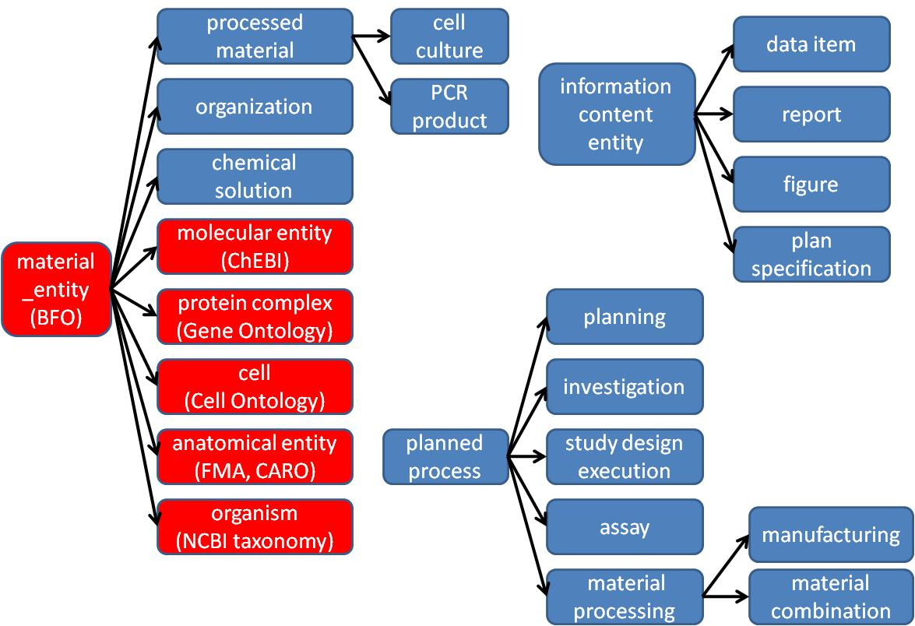

Figure 1 – Partial high-level structure of OBI classes. OBI and Information Artifact Ontology (IAO) classes are shown in blue. Classes imported from other external ontologies are shown in red. Some example subclasses, such as PCR product and cell culture are included to illustrate the use of the class processed material.

Material entity
Within BFO, entities made up of matter are represented using the BFO classes of object, object part and object aggregate. The use of these BFO classes is appropriate if all entities are of similar scale. However, entities in biomedical investigations span sizes from molecules to populations of organisms. Depending on the level of granularity chosen, these might be considered unitary objects or aggregates of smaller parts. Therefore, the class material entity was created in BFO at the request of OBI developers as the union of object, object part and object aggregate. By using material entity as our root class we avoid committing to the granularity schema in BFO.
Several subclasses of material entity are imported from external ontologies: Classes under organism are imported from the NCBI taxonomy¹⁵, anatomical entity and its subclasses from the Foundational Model of Anatomy¹¹ or the Common Anatomy Reference Ontology¹⁶, and the molecular entity hierarchy from ChEBI¹⁷. OBI-specific classes using these imports were then constructed. For example, a chemical solution such as a PBS buffer can be defined by referencing the molecules defined in ChEBI from which the buffer is made. Table 1 gives the complete metadata describing the PBS buffer class.
Table 1: Example metadata for class OBI_0100046.
Annotation property | Example | Usage
Preferred Term* | phosphate buffered saline solution | The concise, meaningful, and human-readable name for a class or property that reflects community usage, or disambiguates the term
Definition* | Phosphate buffered saline (abbreviated PBS) is a buffer solution commonly used in biochemistry. It is a salty solution containing sodium chloride, sodium phosphate and in some preparations potassium chloride and potassium phosphate. The buffer helps to maintain a constant pH. The concentration usually matches the human body (isotonic). | The Aristotelian definition, explaining the meaning of a class or property
Definition Editor* | Philippe Rocca-Serra; Tina Boussard; Melanie Courtot | The editors
Definition Source* | http://en.wikipedia.org/wiki/Phosphate_buffered_saline | A traceable reference to the source of the definition
Curation Status* | Ready for release | The curation status of a class or property, one of: uncurated; metadata incomplete; metadata complete; pending final vetting; ready for release; placeholder
Example | PMID: 16279733. Dent Mater J. 2005 Sep;24(3):414-21. PBS buffer solutions with different pH values can change porosity of DNA-chitosan complexes. | A phrase describing how the term is used
Alternative Term | PBS buffer | A synonym for the class or property
* required metadata.
Material entities that result from intentional acts are processed material. For example, a specimen collected in a clinical protocol is a processed material, as is a measurement device, such as an array scanner, which is manufactured with the intent to perform a function. A material entity such as a protein can be produced intentionally, for example using a recombinant expression system, or naturally expressed in an organism. Class hierarchies with multiple inheritance can become difficult to maintain; therefore, processed material is logically defined with necessary and sufficient conditions, as exactly those material entities that are specified output of a process of material processing. This allows automated reasoners to infer subclasses. For example peptide construct (which is asserted as a subclass of material entity) is inferred by the reasoner to be a subclass of processed material, as it is specified output of some enzymatic ligation.

Planned Processes
The OBI definition of material processing is a type of planned process. Such processes are initiated by an agent (typically a person) to achieve a certain goal. OBI captures such goals by defining an objective specification, which is a subclass of information content entity. An example objective specification is the phrase “Hybridize RNA to chip” in a manuscript describing a microarray gene expression protocol¹⁸. When a process is performed to meet an objective specification it is a planned process. The majority of processes represented in OBI are planned processes. OBI uses the relation achieves planned objective between a planned process and a corresponding objective specification. A single planned process can achieve more than one objective. The planned process hierarchy of OBI represents realizations of broad objectives. These include material component separation, where, for example, a cell sorter is used to separate CD8+ cells from other cells in a blood specimen, and material combination, such as when a chemical is added to a cell culture.
While processes can have many participants, objective and plan specifications explicitly identify important participants. For example, while the light source used to illuminate a laboratory is not normally specified in a mass spectrometry experiment, the use of a mass spectrometer always is. OBI defines two relations, has specified input and has specified output, relating planned process instances to participants that are explicitly identified in their plan specification. Specified outputs must be present at the end of a process for it to achieve its objective specification. Specified inputs are identified in the plan specification and are not created during the process. Figure 2 gives an example of how two planned processes, drawing blood and measuring its glucose concentration, are represented. OBI also includes processes such as data transformation, which have data items, as opposed to material entities, as the input and output. For example, the OBI class mean centering achieves a data normalization objective.

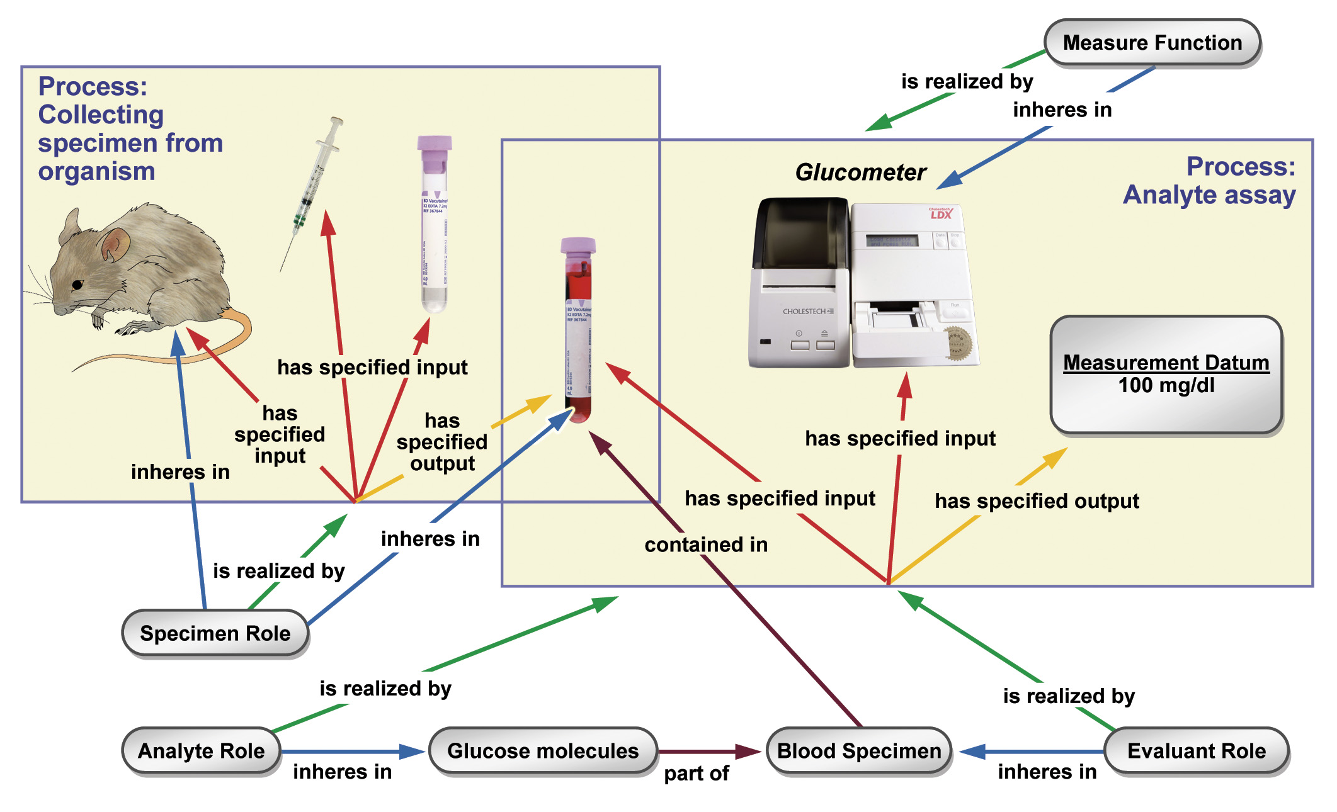
Figure 2. Measuring the glucose concentration in blood. The large boxes represent processes and their participants. The collecting specimen from organism process takes place first. In this process, a syringe is used to draw blood from the mouse, which bears the specimen role. At the end of this process, a tube contains the blood specimen. In a second process, this specimen will be used in an analyte assay, which measures the concentration of glucose in the blood. A glucometer is used to make this measurement. The analyte role inheres in the glucose molecules scattered throughout the blood specimen. This planned process achieves the analyte (i.e. glucose) measurement objective.
Information entities
Any ontology of biomedical investigations needs to represent information such as data, investigation designs and reports of investigation results. The Information Artifact Ontology (IAO¹⁹) grew out of OBI efforts to capture these investigational entities. IAO was created to provide a higher-level general ontology in recognition of the need to capture information outside of the scope of OBI (e.g., law-related).
The root class of IAO is information content entity, which describes all information that is intentionally created. All information content entities share two features; they are generically dependent, so they must be borne by at least one other entity; and, that they are about other entities. The is about relationship does not describe the structure or format of the information; rather, it describes the entity the information itself describes. So, the glucose concentration measurement in Figure 2 is about a molecular concentration quality of the specimen.
For OBI, an important subclass is directive information entity, such as a plan specification or an objective specification, which an experimenter would read to learn how or why to perform a certain experiment. IAO also defines documents such as journal articles or patents, and their parts such as a table, figure or scatter plot.
OBI then defines subclasses of information content entity that are specific to investigations. These include protocol and study design, which are types of plan specification, representing the specification of a single procedure or an entire investigation, respectively. An important part of many study designs is the identification of independent variable specifications, which can specify that the concentration of a chemical will be varied in otherwise identical cell cultures,,and dependent variable specifications, such as that the proliferation rate in the cell culture will be measured as a function of the chemical concentration. Central to investigations are the types of data generated. These include measurement datum, obtained in an assay, and many subclasses for specific types of assays. For example, scalar measurement datum represents measurement data composed of a numeral and a unit label (e.g. length measurement datum, about length quality instances). Finally, the interpretation of information generated during the study design execution is documented as a conclusion textual entity.

Roles and Functions
A role as used in OBI and defined in BFO has two properties: first, the entity that bears the role, and second the process in which the role is realized. A role is not essential to the entity bearing that role, but is demonstrated under certain circumstances when the role is realized. For example, humans can bear specific roles relating to investigations including the investigation agent role, realized by contributing to the completion of an investigation, and the author role, realized by writing a report. Additionally, OBI contains roles defined by the study design of an investigation. The results of a study can be about any material entity, including humans, tissue or molecules; so they would bear a study subject role. Similarly, the reference substance role can be borne by different entities specified in the study design that are included to support the observed differences between entities being studied. OBI also contains roles defined in specific experimental procedures, such as the analyte role or calibration substance role.
Functions differ from roles in BFO in that they are intrinsic to an entity because of structural organization²⁰. For example, OBI defines that a polystyrene tube and an animal cage bear the contain function, while a measure function inheres in a gamma counter.

Organization
OBI needs to represent organizations to identify, for example, Affymetrix as the manufacturer of a microarray. Placing organization into the BFO hierarchy proved controversial, as good arguments were made for treating it either as a material entity or an immaterial kind of social construct related to other legal entities. The latter are not currently well described in BFO. Our solution is to define an organization by things that are true about it: an organization is a continuant entity that can bear roles and has members. Members of organizations are either organizations in themselves or individual human beings. Members can play organization-specific member roles. This definition is broad enough to include for example a regulatory agency like the U.S. Food and Drug Administration.

Applications of OBI
In November 2009, the OBI ‘Philly’ release was made available published that supported several uses cases such as applicability to a building data analysis genomics workflows, querying queries of an OBI-enabled databases queries, and the representing annotation of a clinical investigations from detailed individual experiments to high level study designs. Since then, OBI has been adapted in practice, and is usedd in multiple projects including the four five described next.
Adding semantic expressivity to data stored in the IEDBRepresentation of experiments mapping targets of immune responses in IEDB
The Immune Epitope Database (IEDB) catalogs experiments that characterize the location and function of immune epitopes in infectious agents, allergens, transplants and auto-antigens. Information is entered into the IEDB through author submissions and through manual curation of the scientific literature. Over 380,000 experiments have been entered into the IEDB to date and manual curation is on track to cover more than 95% of all relevant journal articles ever published by the end of 2011. Like many databases, information in the IEDB comes mostly in the form of values from controlled lists. Where available, existing ontologies were used as a source for terms on such lists, but for many types of information controlled vocabularies had to be developed by the IEDB team. Building and maintaining controlled vocabularies that deal with changing naming conventions over decades of scientific practice is a significant task. Worse, it is a thankless task, as the work has limited value outside of the IEDB itself.
To address this issue, the IEDB team has worked with multiple ontology developers to extend e.g. GO, ChEBI, PRO and PATO to replace IEDB internal controlled vocabularies. By far the largest contribution was made by OBI, which not only covers terms specific for experiments and investigations, but also provides the framework that explains how terms from other ontologies are related to each other in the context of an experiment. Figure X depicts how the list of T cell assay types used in the IEDB has been mapped to OBI. The T cell assay classes in OBI are constructed using logical definitions that tie them to GO terms representing the biological processes interrogated by the assays such as IFN-gamma production, and to more general experimental techniques represented in OBI such as ELISA or FACS assays.
Using OBI as a source of assay terms in the IEDB has replaced plain lists of strings and given them expressive textual and logical definitions. This enables interoperability with other knowledge resources. For example, if RNA-sSeq data shows that T cells from asthmatic patients overexpress genes involved with particular GO biological processes, the IEDB data can now easily be interrogated for experiments that show T cell involvement in these biological processes following auto-antigen and allergen recognition. There are also multiple benefits in the maintenance of terms for the IEDB team. It is now easier to identify redundant entries as the use of GO terms provides synonyms to indicate that ‘X production’ is equivalent to ‘Y production’, and because logical reasoning flags equivalent entries upon their creation, Logical reasoning also organizes terms into a hierarchy without the need for human intervention. Such a hierarchy eases navigation of flat lists with hundreds of entries, and enables querying for more general terms such as ‘cytokine production assays’.
Designing smart, standardized submission forms
BJOERN TODO
EuPathDB annotation of datasets associated with for EuPathDBeukaryotic pathogens
The Eukaryotic Pathogen Database (EuPathDB; http://eupathdb.org) project integrates genomic and functional genomics data from over 30 different protozoan parasite species. Protozoan parasites are a major cause of global human and veterinary infectious diseases, such as malaria, toxoplasmosis, cryptosporidiosis, Chagas disease, sleeping sickness and leishmaniasis. EuPathDB also integrates aims to integrate data on specific isolates of parasites, their genotypes, isolate data, and effects of genetic manipulation on the phenotype. However, currently available data on parasite isolates and genetic manipulation is highly heterogeneous and therefore hard to query and represent due to lack of community- accepted standards.with resulting phenotype data but in a limited manner due to the heterogeneity of what is currently obtained.

To better standardize data as it is being captured, the EuPathDB team and user communitiesy decided to develop submission forms. OBI was chosen as the basis for developing submission these forms to capture these types of data directly from investigators in a standardized manner. OBI was chosen because it provides a framework for modeling the generation of the desired data through its use of planned processes in which external ontologies can easily be referenced including assays. In OBI, description of the genotype of an isolate is done by referring to the process of specimen collection that resulted in the physical isolate, followed by the sequencing experiment performed on the isolate, which then resulted in information about its genomeic data. For example, rather than start with an “isolate” and decide what attributes it has that we want to capture, we instead started with the process of specimen collection. This informed us as to what are the inputs and outputs of that process. Once an isolate specimen is created as output, it can then be used in a sequencing assay to generate data on the genotype of the isolate. With the inputs and outputs of these planned processes we could We consulted with investigators performing these processes and established what was needed neededto be captured in the form. The result was a form that captures details about the process of creating an isolate specimen (where, when, and from what was it collected) and performing a sequencing assay (to obtain isolate sequence data). In this example, the terminology used for describing each instance of an isolate specimen is drawn mainly from other ontologies (e.g., GAZ, PATO). OBI is used for categories of terms needed (e.g., sequence data) and for relating the information collected on the form for loading into a databasesing and subsequent data mining.
The same approach is being used for the more complex task of capturing phenotype information resulting from genetic modification of parasites. Insights into the function, location, and biological processes for parasite proteins of interest are found through genetically modifiedgenetic modification such as knocking out the expression of the gene encoding the protein or tagging it with a fluorescent marker. Also of interest is the effect of these modifications on the viability, infectivity, and proliferative ability of the parasite. The key planned processes used to model this case are genetic transformation and assay (both drawn from OBI). In addition to using OBI terms to relate collected information for EuPathDB databases, t. They will also be used to guide what is presented to the user on a web-based form to reduce the burden of filling out the form by only requesting relevant information.

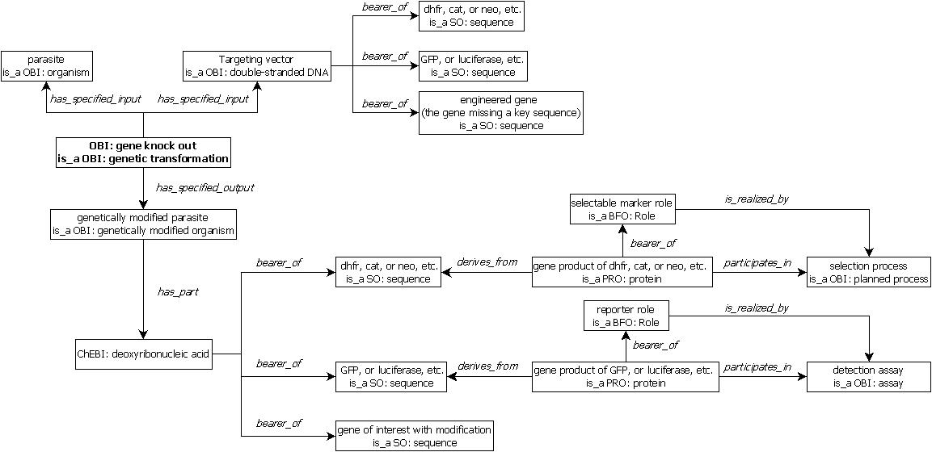

Rresearch Rresource Ddiscovery
An important challenge in biomedical research is the ability to find relevant scientific resources. The majority of resources generated in the course of biomedical research are never publically documented in the literature, catalogs, or lab web sites. Those that are advertised through such channels have proven challenging to discover in a reproducible and efficient way, as they are dispersed across a complex information landscape, described using inconsistent standards or language, and lack information connecting them to related entities such as organisms, genes, genotypes, site of action, biological processes, or diseases. For example, a search for an antibody that can be used to recognize the GFAP protein in rat brain in an immunostaining assay is seemingly simple, yet difficult to accommodate. Giving researchers semantically linked information about available resources can reduce time-consuming and expensive duplication of resource development and promote reuse of existing resources and collaboration. The eagle-i [1], NIF [2], VIVO [3], and Biositemaps [4] projects all have as their mission to improve search and discovery of research resources. Since developing multiple incompatible standards would negate the vision of seamless resource navigation, these organizations have collaborated in aligning their ontologies by reusing common terms and definitions, with the goal of migrating to usage of the same ontology classes and URIs.
Due to its scope, quality, and community development practices, OBI was identified as the ideal ontology in which to develop a common representation of research resources to be reused by these four projects. Thus far, alignment efforts have focused on instruments, services, organismal genotypes and antibodies. Fig. 3x illustrates the representation of a DNA sequencing service within OBI as an example of a unified representation for reuse across the different resource discovery systems.
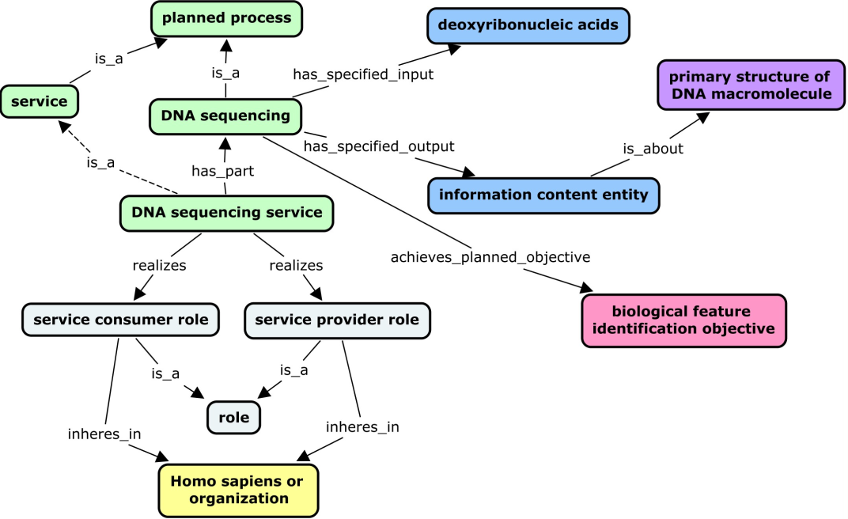

Figure 3x. DNA sequencing service as an example of a service design pattern. Services are typically offered by core laboratories, which perform some planned process (for example, an assay or a material production) for a customer. Like planned processes, services are also linked to entities such as protocols, instruments, specimens, reagents, and objectives. However, key features that distinguish services from the planned processes they perform are the additional processes entailed in a service (order placement, billing, etc.). In addition, services necessarily have service providers and service consumers as participants. To capture these distinctions and allow query using these search facets, a design pattern was used in which a service has_part some planned process and realizes some ‘service consumer role’ and ‘service provider role’ which inheres_in a person or organization.

Shortcut relations. From an application point of view, eagle-i and NIF sometimes required a simplified representation from that available within OBI. For instance, a single property to relate a service to a core laboratory providing that service was required by the eagle-i user interface, rather than using OBI’s composed relation built from two properties to connect an organization to the service it provides (‘organization’ ‘bearer_of’’ some ‘service provider role’ and ‘realized_by’ some ‘service’). We logically collapsed this complex statement with a single property linking a service to its provider (‘service provider’ ‘provides_service’ ‘service’) where ‘service provider’ is defined as follows: (‘organization’ or ‘Homo sapiens’) and (‘bearer_of’ some ‘service provider role’). This need to simplify complex relation chains is a common issue in using ontologies for data collection applications, and ‘shortcut relation’ approaches like the ones suggested in [5] should be exploited. The reuse of OBI within NIF and eagle-i has provided a valuable use case for developing best practices around reuse of ontologies within software applications. Use of OBI across different applications will allow publication of resources as Linked Open Data under a common representation. Investigators will have improved navigability of potential research resources, identification of colleagues for collaboration, and exploration of novel research connections.

[1] Torniai, C., Bashor, T., Bourges-Waldegg, D., Corday, K., Frost, H.R., Johnson, T., Segerdell, E., Shaffer, C.J., Stone, L., Wilson, M.L., Haendel, M.A. (2010) eagle-i: an ontology-driven framework for biomedical resource annotation and discovery. Bio-Ontologies 2010: Semantic Applications in Life Sciences, ISMB 2010 (Boston, MA).

[2] Gupta A., Bug W., Marenco L., Qian X., Condit C., Rangarajan A., Müller H.M., Miller P.L., Sanders B., Grethe J.S., Astakhov V., Shepherd G., Sternberg P.W., Martone M.E. (2008) Federated access to heterogeneous information resources in the Neuroscience Information Framework (NIF). Neuroinformatics. Sep;6(3):205-17.

[3] Krafft, D.B., Cappadona, N.A., Caruso, B., Corson‐Rikert, J., Devare, M., Lowe, B.J., VIVO Collaboration (2010) VIVO: Enabling National Networking of Scientists. Proceedings of the WebSci10: Extending the Frontiers of Society On‐Line, April 26‐27th, 2010, Raleigh, NC: US.

[4] Tenenbaum JD, Whetzel PL, Anderson K, Borromeo CD, Dinov ID, Gabriel D, Kirschner B, Mirel B, Morris T, Noy N, Nyulas C, Rubenson D, Saxman PR, Singh H, Whelan N, Wright Z, Athey BD, Becich MJ, Ginsburg GS, Musen MA, Smith KA, Tarantal AF, Rubin DL, Lyster P. (2010, Oct 16). The Biomedical Resource Ontology (BRO) to enable resource discovery in clinical and translational research. Journal of Biomedical Informatics. Epub ahead of print, doi: 10.1016/j.jbi.2010.10.003.
[5] Mungall CJ, Ruttenberg A, Osumi-Sutherland D. Taking shortcuts with OWL using safe macros. Nature Precedings. 2010. http://precedings.nature.com/documents/5292/version/1/files/npre20105292-1.pdf

Harmonize the annotation across different functional genomics resources
Terminologies, minimum information checklists, and exchange formats are increasingly used in the structuring and annotation of data sets, but in many cases the lack of coordination between their developers, who normally cater only to their own community, brings significant challenges. This diversity of standards hinders discovery, because only those able to navigate the various available terminologies and formats can associate and integrate information scattered across incompatible databases. The importance of unlocking the value of shared datasets to accelerate discovery requires new models for the way we collaborate [1, 2, 3].
The Investigation, Study, Assay (ISA) framework is an exemplar approach that illustrates the concept of synergizing as a way to build productive infrastructural relationships among data producers, consumers and service communities. The core elements of the collaborative ISA framework are an open source ISA software suite and an extensible hierarchical data structure [4], whose model has informed the structure of OBI and provided terms for populate its classes. ISA and OBI have been implemented by a growing number of international public resources [listed at 5] that cater to data as diverse as stem cell, toxicogenomics, environmental gene surveys, microbial diversity studies, and a variety of metabolomics and metagenomics-based studies to maintain cross-domain compatibility in the way the experimental context is described.
In its most basic form, OBI is used as a source of controlled terminology to describe assays and instruments, as well as biological material and data manipulation protocols. One of the ISA software component, ISAconfigurator, ties up relevant OBI entities in ISA table definitions, via calls to NCBO BioPortal [6]. Figure Xa details how assay tables can be declared while figure Xb shows how protocols, used in canonical ISA workflows, may be typed with OBI process classes. Uploaded to the ISAcreator, the editor component, these configurations guide the users in the annotation process, enabling curation at the sources. This novel approach offers experimentalists the opportunity to start taking data management into their own hands, becoming active consumers of community terminologies. In a more advanced use, the ISAvalidator component reads the configurations files and relies on OBI to carry out semantic validation and error detection, e.g., by inspecting protocols referenced between elements of the ISA structure. Developments are ongoing to further check the semantics of data matrices by inspecting reported data transformations and data matrix quantitation types (e.g. a q-value (OBI_ 0001442) should be present in the data matrix file if a false discovery rate correction method (OBI_0200163) is reported).
The combination of ISA and OBI illustrates the power of a ‘horizontal’ synergistic approach to engender networks that go beyond individual life science domain- or assay technology-focused communities. As the ISA community works to expose the experimental metadata to the world of Linked Data, OBI is set to provide the backbone classes for RDF representation and its object properties are used to make explicit the relations between ISA syntactic elements.
[1] Data's shameful neglect, Nature 461, 145 (2009)
[2] Dealing with data, Science, 331, 692 (2011).
[3] Field D, Sansone SA, Collis A, Booth T, Dukes P, Gregurick SK, Kennedy K, Kolar P, Kolker E, Maxon M, Millard S, Mugabushaka AM, Perrin N, Remacle JE, Remington K, Rocca-Serra P, Taylor CF, Thorley M, Tiwari B, Wilbanks J. Megascience. 'Omics data sharing. Science. 2009 Oct 9;326(5950):234-6.
[4] Rocca-Serra P, Brandizi M, Maguire E, Sklyar N, Taylor C, Begley K, Field D, Harris S, Hide W, Hofmann O, Neumann S, Sterk P, Tong W, Sansone SA.ISA software suite: supporting standards-compliant experimental annotation and enabling curation at the community level. Bioinformatics. 2010 Sep 15;26(18):2354-6. Epub 2010 Aug 2.
[5] ISA communities and data resources: http://www.isa-tools.org/case_studies.html
[6] Noy NF, Shah NH, Whetzel PL, Dai B, Dorf M, Griffith N, Jonquet C, Rubin DL, Storey MA, Chute CG, Musen MA. BioPortal: ontologies and integrated data resources at the click of a mouse. Nucleic Acids Res. 2009 Jul 1;37(Web Server issue):W170-3. Epub 2009 May 29.

Expanding types and clarifying the meaning of “evidence” in the Evidence Code Ontology
The Evidence Code Ontology (ECO; http://www.obofoundry.org/cgi-bin/detail.cgi?id=evidence_code) is a rich ontology for making statements about experimental and other types of evidence, where the root class evidence is defined as “a type of information that is used to support an assertion.” Originally ECO grew out of a list of evidence types that were used to qualify Gene Ontology (GO) annotations at participating databases, such as The Arabidopsis Information Resource (TAIR; http://www.arabidopsis.org), with respect to different experimental types.¹ The goaloriginal intent of ECO from the outset was to provide a set of evidence codes that could be used in conjunction with GO terms, and which were not to be considered outside of the context of GO terms. In its first release on SourceForge ECO contained some 125 terms, which contained the subset of well-known GO terms (http://www.geneontology.org/GO.evidence.shtml).
Eventually, however, the need has arisen for more detailed evidence types for use not only by model organism databases that perform GO annotation and projects related to GO such as Phylogenetic Annotation and INference Tool (PAINT; http://wiki.geneontology.org/index.php/PAINT), but also by external groups such as the Universal Protein Resource (UniProt; http://www.uniprot.org), Ontology of Microbial Phenotypes (http://www.microbialphenotypes.org), Ascidian Network for In Situ Expression and Embryological Data (ANISEED; http://aniseed-ibdm.univ-mrs.fr), and various independent laboratories engaged in independent research programs. The maintainers of ECO have been simultaneously engaged in creating terms to meet the needs of users while attempting to broaden the scope of ECO to allow for general compatibility with groups outside of GO. To that end, we performed an initial revisions of ECO which have resulted in the creation of Aristotelian definitions, the removalwhere an effort was made to convert long text definitions into Aristotelian definitions that did not make of overt references to GOO, in addition to many other improvements, and the. During the the initial cleanup of ECO, it became apparent that ECO was unintentionally representing several mixed concepts, including type of evidence, evaluation of evidence, assignment of evidence, and inference. Eventually a new root class was added in addition to evidenceaddition of a second root class called assertion method, defined as “a means by which a statement is made about an entity.” All terms in ECO now are a type of evidence, an assertion method (manual or automatic), or an internal cross product of assertion method and evidence, i.e. how a given type of evidence is applied to make a given statement. At present, there are 257 terms in ECO.
Despite progress in clarifying what ECO represents, a critical area that needs much more work is to distill what is meant by “evidence” itself. Indeed, at least four meanings of “evidence” are present in the ontology at present (with example term names in italics): class of evidence (e.g. phylogenetic evidence, experimental evidence, or expression pattern evidence), type of analysis performed (e.g. combinatorial analysis, protein binding experiment, or tissue ablation), type of data output from an experiment (e.g. flow cytometry data, chain termination sequencing result, or sequence alignment evidence), or the statement of fact that the data support (e.g. motif similarity or structural similarity). Clearly there is a need to distinguish among the currently used meanings of “evidence” in order to achieve better internal consistency, which will result in an ontology that is easier to develop and maintain, as well as understand by users. To this end, we are using the carefully defined classes of OBI to refine our term meanings and will eventually importcreate ECO terms based on OBI terms to expand the types of evidence the ECO covers. Likewise, OBI will benefit from incorporating the types of experiments and processes used to generate evidence types found in ECO, that are not yet found in OBI. In this way both ontologies will benefit.
ECO and OBI are orthogonal ontologies because OBI is built around planned processes, whereas ECO classes are information artifacts. We intend for many ECO evidence types to be defined as specified outputs of OBI planned process and its subtypes, including assay and data transformation. For example, ECO:0000224 SOLiD sequencing result would be a specified output of the OBI class SOLiD sequencing (Figure). The ECO term would carry the database cross reference (dbxref) to its OBI counterpart SOLiD sequencing.
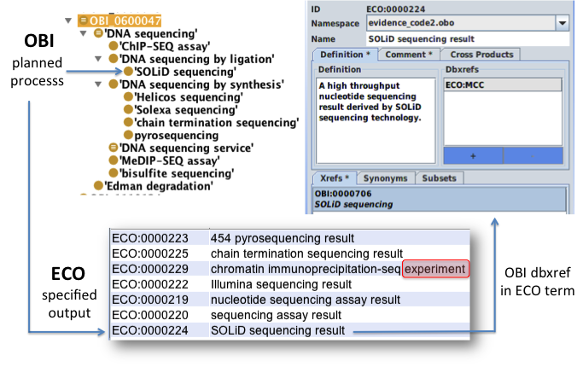
Figure. Many ECO terms will be created or validated against OBI, by making ECO terms specified outputs of OBI planned processes. ECO:0000224 SOLiD sequencing result is an output from the planned process SOLiD seuquencing in OBI. The connection will be made in the xref field of the ECO term, shown here in OBO-Edit. Viewed in light of OBI, terms like ECO:0000229 chromatin immunoprecipiation-seq experiment, highlighted in red, immediately appear as inconsistent with other terms in ECO, and would be targets for correction to achieve consistency.

Although we don’t expect that all types of evidence in ECO will have counterpart elements in OBI (for example curator inference will not), Further issues require clarification, such as whether all of the types of evidence in ECO, such as curator inference, have a counterpart in OBI. Still, we still believe that it is feasible to make certain domains within ECO and OBI completely interoperablesynergistic.
1. [Nucleic Acids Res. 2004 January; 32(Database issue): D258–D261]

ISA tools and annotation of functional genomics experiments
Use case 4: ISA-OBI synergy to provide a common annotation framework for reporting biological studies

Funders and journals require that researchers share their data, and encourage the enrichment and standardization of experimental context or metadata [ref-1] to make datasets reliable and reusable, particularly if used as the underpinnings of future investigations. This situation demands better annotation at source (by data generators or community-based curation efforts), using open source software with automated content validation [ref-2]. The ISA community is an example of a growing number of international public and internal resources that implement and contribute to the development of the ISA tools [ref-3] - the ISA-Tab format and ISA software components - in diverse life science scenarios, including toxicogenomics, stem cell genomics, environmental genomics and metagenomics [ref-4].
In this context, ISA can rely on OBI ontology in several ways. In its most basic form, ISA tools uses OBI as a controlled vocabulary to describe assays and instruments, as well as biological material and data manipulation protocols. In practice, ISAconfigurator tool ties up relevant OBI entities in ISA table definitions, via calls to NCBO bioportal [ref-5]. Figure Xa details how assay tables can be declared while figure Xb shows how protocols, used in a canonical ISA workflows, may be typed with OBI process classes for each assay worflow.
When used in ISAcreator, the ISA format editor, those configurations guide users in their annotation process. ISA approach has been validated by managing experimental metadata from various domains, from environmental gene surveys (OBI:to be submitted) used in microbial diversity studies to multi-omics toxicogenomics studies [ref-6,7,8] and single nucleotide resolution nucleic acid structure mapping assays (OBI_0000870) (Rocca-Serra et al, submitted). We have also demonstrated how the tools could be used recording flow cytometry data and are currently working with the MIBBI [ref-9] project to extend to other domains and convince of the usefulness of OBI as core resources for data integration.

In a more advanced use, ISAvalidator, reading ISAconfigurations, relies on OBI to carry out semantic validation and error detection by inspecting protocols referenced between ISA node elements. Developments are ongoing to further check the semantics of data matrices by inspecting reported data transformations and data matrix quantitation types (e.g. a q-value (OBI_xxx) should be present in the data matrix file if a false discovery rate correction method (OBI_0200163) is declared).

Finally, a more complex use of OBI in ISA infrastructure can be found in the ISAconverter RDF conversion component. This module exposes experimental metadata to the world of Linked Data. OBI then provides backbone classes for RDF representation of ISA studies while OBI object properties can be use to make explicit the relations between ISA syntactic elements without necessarily having to resort to the OWL expressivity and possibly complexity.

1.
PMID:19815759
Field D, Sansone SA, Collis A, Booth T, Dukes P, Gregurick SK, Kennedy K, Kolar P, Kolker E, Maxon M, Millard S, Mugabushaka AM, Perrin N, Remacle JE, Remington K, Rocca-Serra P, Taylor CF, Thorley M, Tiwari B, Wilbanks J. Megascience. 'Omics data sharing. Science. 2009 Oct 9;326(5950):234-6.

2.
PMID: 18769432
Howe D, Costanzo M, Fey P, Gojobori T, Hannick L, Hide W, Hill DP, Kania R, Schaeffer M, St Pierre S, Twigger S, White O, Rhee SY. Big data: The future of biocuration. Nature. 2008 Sep 4;455(7209):47-50.

3.
PMID:20679334
Rocca-Serra P, Brandizi M, Maguire E, Sklyar N, Taylor C, Begley K, Field D, Harris S, Hide W, Hofmann O, Neumann S, Sterk P, Tong W, Sansone SA.ISA software suite: supporting standards-compliant experimental annotation and enabling curation at the community level. Bioinformatics. 2010 Sep 15;26(18):2354-6. Epub 2010 Aug 2.

4. ISA community and case studies: http://www.isa-tools.org/case_studies.html

5.
PMID: 19483092
Noy NF, Shah NH, Whetzel PL, Dai B, Dorf M, Griffith N, Jonquet C, Rubin DL, Storey MA, Chute CG, Musen MA. BioPortal: ontologies and integrated data resources at the click of a mouse. Nucleic Acids Res. 2009 Jul 1;37(Web Server issue):W170-3. Epub 2009 May 29.

6.
PMID: 20888850
Ellinger-Ziegelbauer H, Adler M, Amberg A, Brandenburg A, Callanan JJ, Connor S, Fountoulakis M, Gmuender H, Gruhler A, Hewitt P, Hodson M, Matheis KA, McCarthy D, Raschke M, Riefke B, Schmitt CS, Sieber M, Sposny A, Suter L, Sweatman B, Mally A. The enhanced value of combining conventional and "omics" analyses in early assessment of drug-induced hepatobiliary injury. Toxicol Appl Pharmacol. 2011 Apr 15;252(2):97-111. Epub 2010 Oct 1.

7.
PMID: 21081137
Matheis KA, Com E, Gautier JC, Guerreiro N, Brandenburg A, Gmuender H, Sposny A, Hewitt P, Amberg A, Boernsen O, Riefke B, Hoffmann D, Mally A, Kalkuhl A, Suter L, Dieterle F, Staedtler F. Cross-study and cross-omics comparisons of three nephrotoxic compounds reveal mechanistic insights and new candidate biomarkers. Toxicol Appl Pharmacol. 2011 Apr 15;252(2):112-22. Epub 2010 Nov 21.

8.
PMID: 21315101
Boitier E, Amberg A, Barbié V, Blichenberg A, Brandenburg A, Gmuender H, Gruhler A, McCarthy D, Meyer K, Riefke B, Raschke M, Schoonen W, Sieber M, Suter L, Thomas CE, Sajot N.A comparative integrated transcript analysis and functional characterization of differential mechanisms for induction of liver hypertrophy in the rat. Toxicol Appl Pharmacol. 2011 Apr 15;252(2):85-96. Epub 2011 Feb 26.

9.

PMID:18688244
Taylor CF, Field D, Sansone SA, Aerts J, Apweiler R, Ashburner M, Ball CA, Binz PA, Bogue M, Booth T, Brazma A, Brinkman RR, Michael Clark A, Deutsch EW, Fiehn O, Fostel J, Ghazal P, Gibson F, Gray T, Grimes G, Hancock JM, Hardy NW, Hermjakob H, Julian RK Jr, Kane M, Kettner C, Kinsinger C, Kolker E, Kuiper M, Le Novère N, Leebens-Mack J, Lewis SE, Lord P, Mallon AM, Marthandan N, Masuya H, McNally R, Mehrle A, Morrison N, Orchard S, Quackenbush J, Reecy JM, Robertson DG, Rocca-Serra P, Rodriguez H, Rosenfelder H, Santoyo-Lopez J, Scheuermann RH, Schober D, Smith B, Snape J, Stoeckert CJ Jr, Tipton K, Sterk P, Untergasser A, Vandesompele J, Wiemann S. Promoting coherent minimum reporting guidelines for biological and biomedical investigations: the MIBBI project.Nat Biotechnol. 2008 Aug;26(8):889-96.

Query class expression:
‘journal article’ and 'is about' some (investigation
and (has_part some (assay and (has_specified_output some ('is about' some 'cytokine production'))))
and (has_part some (assay and (has_specified_output some ('is about' some 'T cell mediated cytotoxicity')))))
Instances classified as members of this class (identified by Pubmed IDs):
10432283 - Kerksiek, J Exp Med, 1999
11851899 - Lancaster, J Viral Hepat, 2002
15627979 - Engelhardt, Eur J Immunol, 2005

Discussion
OBI is a community-driven ontology that represents biomedical investigations in a computationally amenable form. It enables the representation of investigations across disparate biomedical disciplines and is capable of doing so in a rich, precise and explicit way. As such it is the first substantial cross-community attempt to support the annotation of the experimental context of biomedical data.
OBI fits in a broader framework. Since the Gene Ontology (GO) demonstrated the utility of a controlled, shared and explicit description of gene function, there has been a substantial growth in efforts to describe knowledge in biology. OBI integrates, supports and extends many of these efforts including the formation of an Information Artifact Ontology. It provides a vocabulary for use with minimum information standards³. It complies with, and has helped to drive, the OBO Foundry principles^{10, 29}. As more data described using OBI become available, as exemplified by the provided use cases, its utility to the broader biomedical community will continue to increase.
Covering all biomedical investigation gives OBI a broad scope. This is important and necessary if it is to enable data integration across biomedicine. It is unlikely that it would have been possible to address a scope of this breadth without the wider ontology community. Although clearly necessary for biomedical investigations, we have not had to describe, for example, taxonomy, anatomy or genetics; rather, we have reused existing ontologies and have developed the MIREOT specification to support this.
Despite this, the breadth of OBI’s scope still poses a significant challenge. In order to garner the experience and knowledge to describe biomedicine, we have taken a community-based approach. Authors on this paper, for example, cover many disciplines within biomedicine. In itself, this community approach presents a substantial challenge; it is hard to generate consensus, both of terminology and meaning, between individuals from divergent backgrounds. We have addressed this by focusing, firstly, on assigning a clear, precise and unambiguous meaning for each class in the ontology using both the logical and natural language definitions. Secondly, where terminology in sub-disciplines fails to make distinctions in meaning or is inconsistent between communities, we have addressed this with the liberal addition of synonyms and with examples of usage for every class within the ontology.
While reuse of other ontologies has been critical to OBI, it also creates challenges. External ontologies are often large and are subject to change with independent release policies: importing such large ontologies impacts on the scalability of the tools; independence may require consequent changes in OBI. We have addressed these issues with the development of the MIREOT mechanism which enables partial import of external ontologies¹⁴. Despite this, the size of the resulting ontology is significant and this has identified some shortcomings in the tooling. While Protégé has worked well as an editing tool, it requires craft knowledge for use with an ontology of this complexity. In particular, integration with versioning systems, essential for distributed development, is currently limited. Similarly, OWL has enabled computational reasoning, which is valuable for both use and development of the ontology. However, current reasoning tools do not provide a transparent explanation and debugging facility; likewise, performance is unpredictable and can change significantly between versions of OBI. The community continues to improve these tools and OBI has benefited from communication with their developers.
OBI is complex, but then so are ‘materials and methods’ sections as they stand. There are ways of masking this complexity from end users, if required. One example is the Investigation, Study, Assay (ISA) infrastructure for data sharing^{4,30}, which provides tools to configure and complete reports for specific types of biomedical investigations. The tools can set the minimal fields³ required and restrict each of them to appropriate terms from OBI or other OBO ontologies without requiring the end user to have in-depth understanding of these. Similarly, we wish to ease the submission of new terms from the community to OBI. One method developed for this purpose utilizes template spreadsheets to create composite terms according to pre-defined design patterns³¹. We expect that more such tools will be developed that take full advantage of OBI internally, while providing an end user friendly interface.
In summary, OBI represents a substantial and significant effort to describe biomedical investigations in a consensual, wide-ranging and computationally amenable way. Ontologies such as OBI are essential to rise to the challenges of large-scale biology, safeguard the inheritance of experimental data for the future, and maximize its usefulness in the present.

Acknowledgments
We dedicate this work to the memory of Bill Bug. We want to acknowledge contributions by Eric Deutsch, Dawn Field, Jeff Grethe, Mervi Heiskanen, Matthew Pocock, Joe White, John Westbrook, Helen Causton, Cristian Cocos, Tanya Gray, Jason Greenbaum, Pierre Grenon, Luisa Montecchi, Chris Mungall, Daniel Rubin, Randi Vita, Stefan Wiemann, and want to thank all contributors to the OBO foundry project. This work was supported by funding from NIH grants and contracts HHSN26620040006C, N01AI40041, N01AI40076, UL1RR024982, P41 HG003619, R01AI081062, U54-DA-021519, P41 HG003619, P41 HG003619, R01EB005034, R01NS058296, U24RR029825, 3UL1RR024153-03S1, 5UL1RR024128-03S1, U54HG004028-06 the Public Health Agency of Canada, Canadian Institutes of Health Research Influenza Research Network (PCIRN), the Michael Smith Foundation for Health Research, EPSRC EP/E002331/1, BBSRC/EPSRC ref BB/C008200/1, EMERALD (project number LSHG-CT-2006-037686), EU NoE NuGO (NoE 503630), EU IP CarcinoGenomics (PL 037712); NERC-NEBC; BBSRC's BB/G000638/1, BB/E025080/1; BB/D524283/1 and RC UK.

Methodology
OBI development been achieved by means of weekly teleconferences and twice yearly face-to-face meetings. Developers are dispersed geographically. As a result, OBI has adopted a specific methodology and many formal conventions, to manage what would otherwise be a chaotic process. This has been critical in ensuring that OBI is a homogenous resource. We describe these conventions here.

Choice of language and metadata conventions
OBI developed a consistent metadata convention associated with classes. The complete specification of the metadata scheme is available [http://purl.obolibrary.org/obo/obi/policy/metadata]. This metadata scheme is itself evolving independently as part of the OBO Foundry, and is being used by other ontologies²⁹.
OBI is developed using the Ontology Web Language 1.0 (OWL³²) as this provides richer semantic support than OBO format - the other commonly used alternative in the biomedical domain. The OWL-DL subset used allows maximum expressivity consistent with the use of reasoning for maintenance and development. The metadata scheme is implemented as OWL annotation properties.

Concurrent development
Concurrent development of OBI was necessary given the number of developers. A review of the existing collaborative ontology development tools failed to identify a single application that met OBI’s requirements. Originally, OBI development was, therefore, organized into branches, with each sub-team working independently on a specific subject area, such as data transformations or roles. With the increasing maturity of OBI, and during the move to the 1.0 release, there was more stability and we adopted a single development line. For change management, we used the industry standard Subversion tool; the current development version of OBI is available from Subversion at http://obi.svn.sourceforge.net/svnroot/obi/trunk/src/ontology.

Integration with existing ontologies
OBI was developed to be complementary to, and integrated with, a framework of existing ontologies in the biomedical domain. The methodological challenges associated with this reuse are discussed here.
A top level ontology can provide guidance in how individual terms or whole ontologies interrelate and is useful when integrating external ontologies. BFO³³ was chosen as the top level ontology as it is stable, publicly available in OWL syntax, and aligned to existing OBO Foundry ontologies, and because there is a community of developers and users. The OBO Relations Ontology¹³ provides relations for OBI, including relations that have been proposed for inclusion into RO but are not yet released. When new relations were defined between classes in OBI, these were based on RO relations wherever possible. These new relations are being submitted as proposals for inclusion in RO.
Four key ontologies are directly imported using the owl:import mechanism, including BFO and RO mentioned above, plus the ro_bfo bridge mapping to specify domains and ranges for properties using BFO and IAO classes.
The owl:import mechanism was not suitable for all external ontologies for two reasons: first, current editing tools are not effective for working with very large ontologies such as the NCBI Taxonomy¹¹, therefore a direct import is not scalable; second, some ontologies used by OBI are actively developed and may not be aligned with OBI methodology, for example they may not use BFO or OWL DL. Importing such ontologies as a whole can lead to inconsistencies or unintended inferences. Instead, the MIREOT import mechanism was developed¹⁴, which relies on a deprecation policy following the practice of the Gene Ontology in that the intended meanings of classes remain stable. Even when the source ontology changes, such modifications are not intended to change the meaning of terms.

Scope limitation to canonical investigations
The scope of OBI includes the representation of successfully completed investigations, which are a type of planned process. A successful investigation may produce negative results, but processes that result in falsified data or during which there were gross errors are out of scope for OBI. For example, if a PCR-SSCP assay fails to detect a sequence variation, it is in scope for OBI. However, if controls performed as part of the assay fail then it is not in scope. We are representing only experiments which have succeeded by their own criteria, to avoid unnecessary complexity in all definitions. This is similar to the decision of the GO Consortium to model only canonical biological processes³⁴.

Term requests and triaging for concurrent development
The majority of terms in OBI were collected from the various communities that intend to use it. Term lists were solicited and collated by a representative of each community (http://obi-ontology.org/page/Consortium) and terms were also submitted through a public term tracker. Each term was then assessed to determine if it was in the scope of OBI. For example, terms like ‘peptide’ and ‘antibody’ are needed to describe immunological experiments, but were available in ChEBI¹⁷ and GO respectively, and were therefore imported. Submitted terms were distributed to an appropriate OBI branch for curation and inclusion in the OWL file, and interaction between branches was achieved through conference calls.

Release and quality control
Users require a traceable, static version of OBI. We have therefore established a monthly release process where multiple OWL files are merged into a single file. The release version of the OBI is reasoned over and contains the fully inferred hierarchy, making it easier to use and view in available tools. Each release is available from a specific URI using the release date as a tag. The most up-to-date file is always available from http://purl.obolibary.org/obo/obi.owl. Releases of OBI are also uploaded to the NCBO BioPortal³⁵ and the OBO Foundry repository¹⁰.
Checks are made prior to release to ensure compliance with OBI policies. Specifically, classes are identified that: do not comply with the minimal metadata policy; have invalid OWL syntax; or, lead to inconsistency when reasoning using Pellet²⁶ or Fact++³⁶. Identifier format and deprecation policies are also enforced. New classes are automatically assigned a permanent and unique identifier on their first release. The release process verifies that all IDs that were present in the previous release are still in use. This follows GO deprecation policy that OBI has adopted: deleted classes are moved to the ObsoleteClass in the OBI hierarchy and stored in a separate file.

References
1. Jones, A.R. et al. The Functional Genomics Experiment model (FuGE): an extensible framework for standards in functional genomics. Nat Biotechnol 25, 1127-1133 (2007).
2. Spellman, P.T. et al. Design and implementation of microarray gene expression markup language (MAGE-ML). Genome Biol 3, RESEARCH0046 (2002).
3. Taylor, C.F. et al. Promoting coherent minimum reporting guidelines for biological and biomedical investigations: the MIBBI project. Nat Biotechnol 26, 889-896 (2008).
4. Sansone, S.A. et al. The first RSBI (ISA-TAB) workshop: "can a simple format work for complex studies?". OMICS 12, 143-149 (2008).
5. Rayner, T.F. et al. A simple spreadsheet-based, MIAME-supportive format for microarray data: MAGE-TAB. BMC Bioinformatics 7, 489 (2006).
6. Orchard, S. et al. Annual spring meeting of the Proteomics Standards Initiative. Proteomics 9, 4429-4432 (2009).
7. Ball, C.A. et al. Standards for microarray data. Science 298, 539 (2002).
8. Sansone, S.A. et al. The metabolomics standards initiative. Nat Biotechnol 25, 846-848 (2007).
9. Field, D. et al. The minimum information about a genome sequence (MIGS) specification. Nat Biotechnol 26, 541-547 (2008).
10. Smith, B. et al. The OBO Foundry: coordinated evolution of ontologies to support biomedical data integration. Nat Biotechnol 25, 1251-1255 (2007).
11. Rosse, C.a. & Mejino, J.L., Jr. A reference ontology for biomedical informatics: the Foundational Model of Anatomy. J Biomed Inform 36, 478-500 (2003).
12. Grenon, P. & Smith, B. SNAP and SPAN: Towards Dynamic Spatial Ontology. Spatial Cognition & Computation: An Interdisciplinary Journal 4, 69-104 (2004).
13. Smith, B. et al. Relations in biomedical ontologies. Genome Biol 6, R46 (2005).
14. Courtot, M. et al. MIREOT: the Minimum Information to Reference an External Ontology Term. Nature Precedings (2009).
15. Wheeler, D.L. et al. Database resources of the National Center for Biotechnology Information. Nucleic Acids Res 34, D173-180 (2006).
16. Haendel, M.A., Neuhaus, F., Osumi-Sutherland, D., Mabee,P.M. & Mejino Jr. J.L.V., M., C.J. and Smith, B. in Anatomy Ontologies for Bioinformatics: Principles and Practice. (ed. D.D.a.R.B. Albert Burger) (Springer, New York; 2008).
17. Degtyarenko, K. et al. ChEBI: a database and ontology for chemical entities of biological interest. Nucleic Acids Res 36, D344-350 (2008).
18. Byrne, M.C., Whitley, M.Z. & Follettie, M.T. Oligonucleotide arrays for expression monitoring. Curr Protoc Hum Genet Chapter 11, Unit 11 12 (2001).
19. Ruttenberg, A. Information Artifact Ontology (IAO).
20. Arp, R. & Smith, B. in Nature Precedings2008).
21. Reich, M. et al. GenePattern 2.0. Nat Genet 38, 500-501 (2006).
22. Peters, B. & Sette, A. Integrating epitope data into the emerging web of biomedical knowledge resources. Nat Rev Immunol 7, 485-490 (2007).
23. Greenbaum, J.A. et al. in ISMBStockholm, Sweden; 2009).
24. Prud’Hommeaux, E. & Seaborne, A. SPARQL query language for RDF. W3C working draft 4 (2006).
25. Musen, M. et al. The Protege ontology editor and knowledge acquisition system. (2006).
26. Evren Sirin, B.P., Bernardo C Grau, Aditya Kalyanpur, Yarden Katz Pellet: A practical OWL-DL reasoner Web Semantics: Science, Services and Agents on the World Wide Web 5, 51-53 (2007).
27. Irhimeh, M.R., Fitton, J.H. & Lowenthal, R.M. Pilot clinical study to evaluate the anticoagulant activity of fucoidan. Blood Coagul Fibrinolysis (2009).
28. Waters, M. et al. CEBS--Chemical Effects in Biological Systems: a public data repository integrating study design and toxicity data with microarray and proteomics data. Nucleic Acids Res 36, D892-900 (2008).
29. Schober, D. et al. Survey-based naming conventions for use in OBO Foundry ontology development. BMC Bioinformatics 10, 125 (2009).
30. Field, D. et al. Megascience. 'Omics data sharing. Science 326, 234-236 (2009).
31. Rocca-Serra, P. et al. Overcoming the Ontology Enrichment Bottleneck with Quick Term Templates. Nature Precedings (2009).
32. Horrocks, I., Patel-Schneider,P.F and van Harmelen, F. From SHIQ and RDF to OWL: The making of a web ontology language. Journal of Web Semantics 1, 7-26 (2003).
33. Grenon, P., Smith, B. & Goldberg, L. Biodynamic ontology: applying BFO in the biomedical domain. Stud Health Technol Inform 102, 20-38 (2004).
34. Ashburner, M. et al. Gene ontology: tool for the unification of biology. The Gene Ontology Consortium. Nat Genet 25, 25-29 (2000).
35. Musen, M. et al. BioPortal: Ontologies and Data Resources with the Click of a Mouse. AMIA Annu Symp Proc, 1223-1224 (2008).
36. Tsarkov, D. & Horrocks, I. FaCT++ description logic reasoner: System description. Lecture Notes in Computer Science 4130, 292 (2006).

Project Name | Project Description | How is OBI used? | Contributes to OBI?
IEDB | IEDB contains data related to antibody and T cell epitopes for humans, non-human primates, rodents, and other animal species. | OBI vocabulary and data models are in use. | yes
Neuroscience Information Framework | NIF is a dynamic inventory of Web-based neuroscience resources, data, and tools accessible via any computer connected to the Internet. | OBI vocabulary covering resource description terms such as services, databases, and instruments. | yes
BRO / Biositemaps | BRO has developed technologies to address locating, querying, composing or combining, and mining biomedical resources.
eagle-i | The eagle-i project is building a searchable network of research resources at research institutions nationwide. | All of the Eagle I data is entered as instances of OBI classes.
ITPPR | The Integrative Tools for Protozoan Parasite Research project will facilitate data integration for protozoan parasite research through use of standardized terms and their application in tools. | OBI is used to develop forms to capture structured meta-data about studies
FGED - MGED Ontology | The Functional Genomics Data (FGED) works with other organizations to develop standards for biological research data quality, annotation and exchange. | Has incorporated the MGED Ontology (MO) into OBI for use in annotating functional genomics studies especially with the MAGE-TAB format. | yes
ISA | The ISA (Investigation/Study/Assay) infrastructure is a user-friendly multi-domain data capture and management suite that allows the searching of OBI for terms to use in data entry. | OBI is the vocabulary served by this tool.
MIBBI | The MIBBI (Minimum Information for Biological and Biomedical Investigations) project features a range of both community-sourced and integrated reporting guidelines. | MIBBI indicates the use of OBI as a source of controlled terms.
CogPO | CogPO represents a group that is building the ontology of cognitive paradigms. | CogPO is working to harmonize with OBI where possible
EFO | Application ontology for ArrayExpress. | EFO uses OBI classes, particularly assays.
Electrophysiology Ontology | The Electrophysiology (EP) Ontology is an effort to develop a national infrastructure for managing, sharing, and analyzing a broad range of cardiac data. techniques.
Influenza Ontology | The Influenza Ontology is an application ontology covering the numerous aspects if influenza virus basic research, and surveillance.
Neural ElectroMagnetic Ontologies | NEMO is developing ontologies for representation and integration of event-related brain potentials (ERPs).
NCBO Annotator | A Web service that tags free text with ontology concepts.
NCBO Resource Index | The NCBO Resource Web service is a system for ontology based annotation and indexing of biomedical data; the key functionality of this system is to enable users to locate biomedical data resources related to particular ontology concepts.
An Ontology for Drug Discovery Investigations | The goal of DDI project is to develop an ontology for the description of drug discovery investigations. | DDI will be compliant with Ontology for biomedical investigations (OBI).
Adverse Event Reporting Ontology | The Adverse Event Reporting Ontology (AERO) is an ontology aimed at supporting clinicians at the time of data entry, increasing quality and accuracy of reported adverse events.
Supplemental Table 1 – Projects utilizing OBI

Supplemental Table 2 – List of terms used in this manuscript and their identifiers

